Important Notes:

* The Game Window Size is : 1280 pixels width and 720 pixels height
* To run the game go to the view package and run the StartView.java

Step 1:

After running StartView.java choose between starting the game or exiting the game.

Step 2:

After staring the game you will have a window separated for every 2 players each player first has to enter their names to know when it is their terms and to choose their heroes

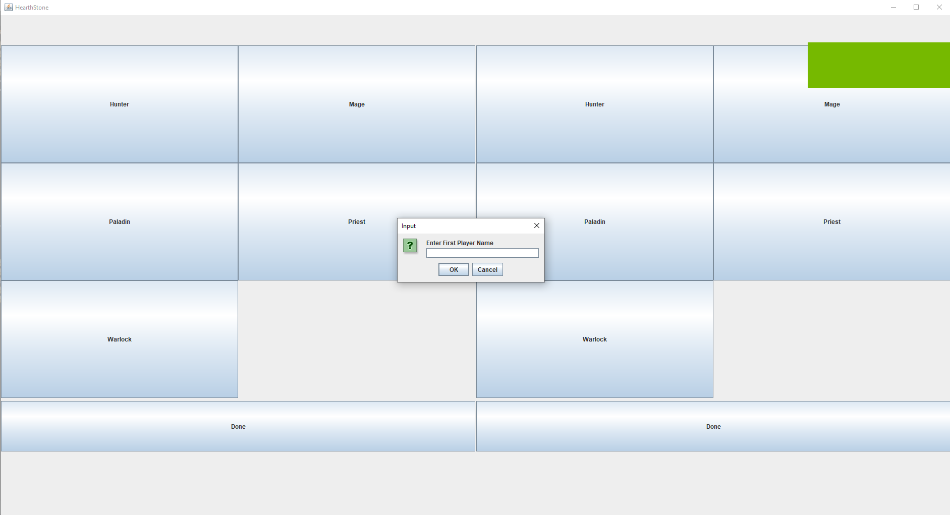

After entering the names of the players each player has to choose their hero by pressing the button of the hero then every player has to press done to start playing the game.

Step 3:

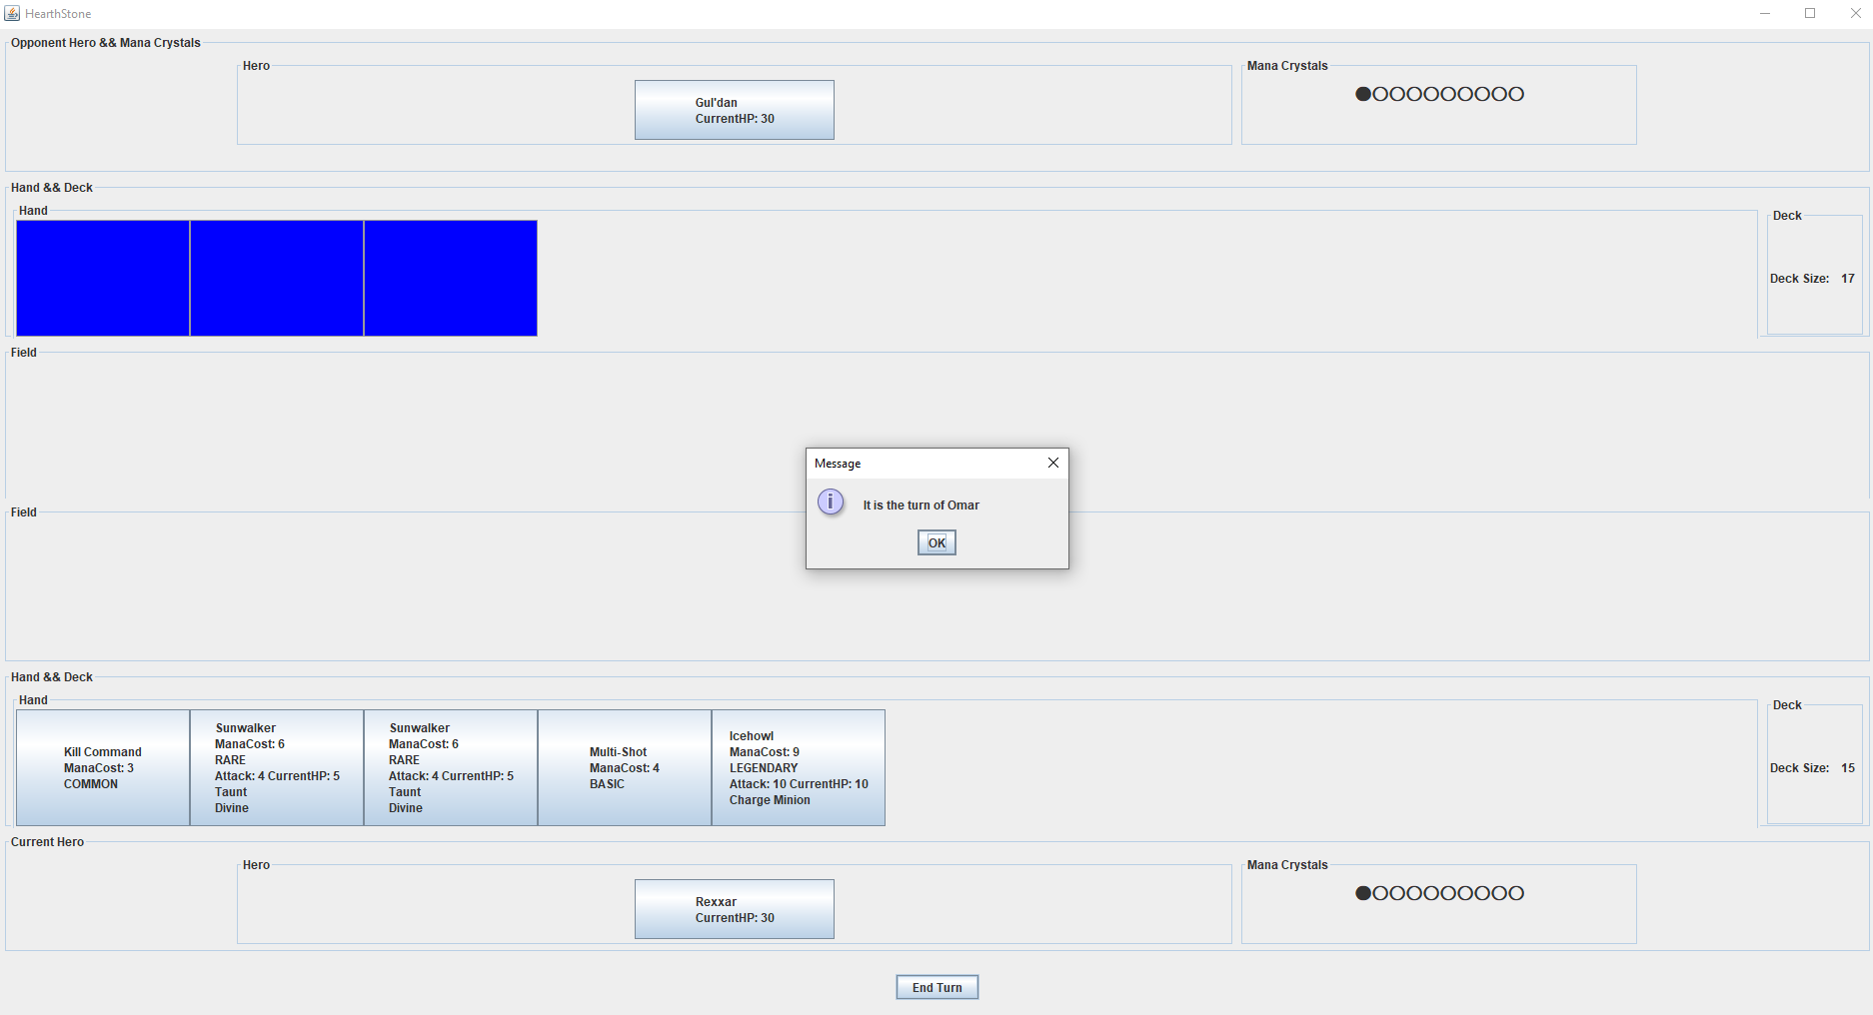The Game Window will open and a message every turn will be displayed to state whose player turn is it. The Player who has the turn is always the one playing at the bottom and the other player which is not his turn is at the top.

End Turn:

To end your turn there is an END Turn button down in the screen click on it.

Play Minion(place a minion from hand to field):

Press on any Minion on the Hand it will be automatically placed in the field if your are eligible to.

Cast Spell:

To play a spell just click on the spell in the hand a small window will open to check if you really want to play this spell.

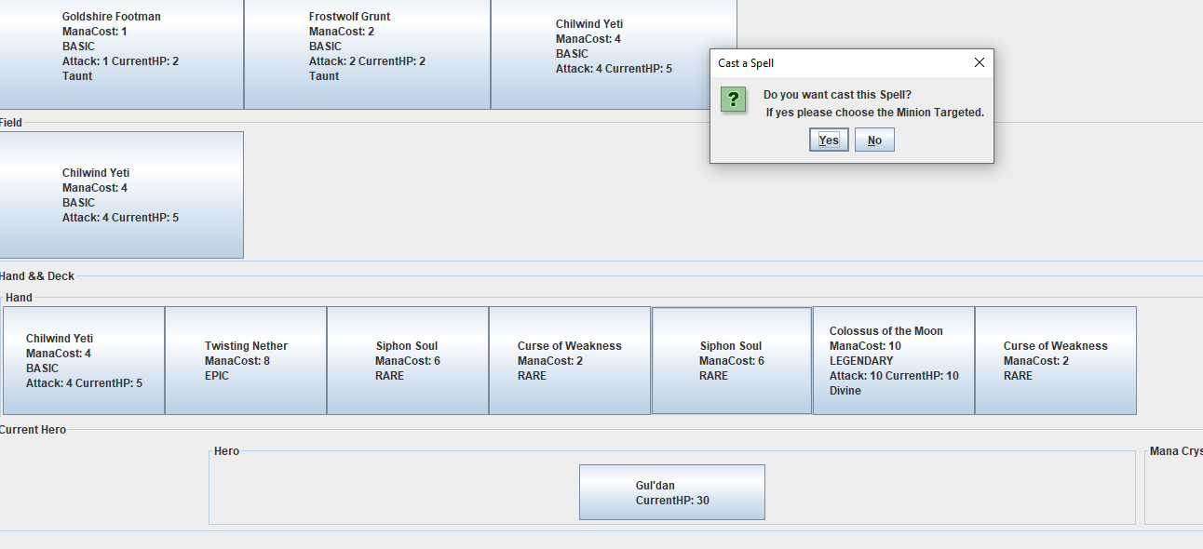If the spell doesn’t need from the user any other data to cast the spell the spell will be played and the effect will be displayed at the same time.

If the spell need another data to be selected after clicking “Yes” for the acceptance to play the spell the buttons you can choose from so the spell can be played on will be the only visible and clickable. The user then need to press on the minion or hero he wants the spell be played on.

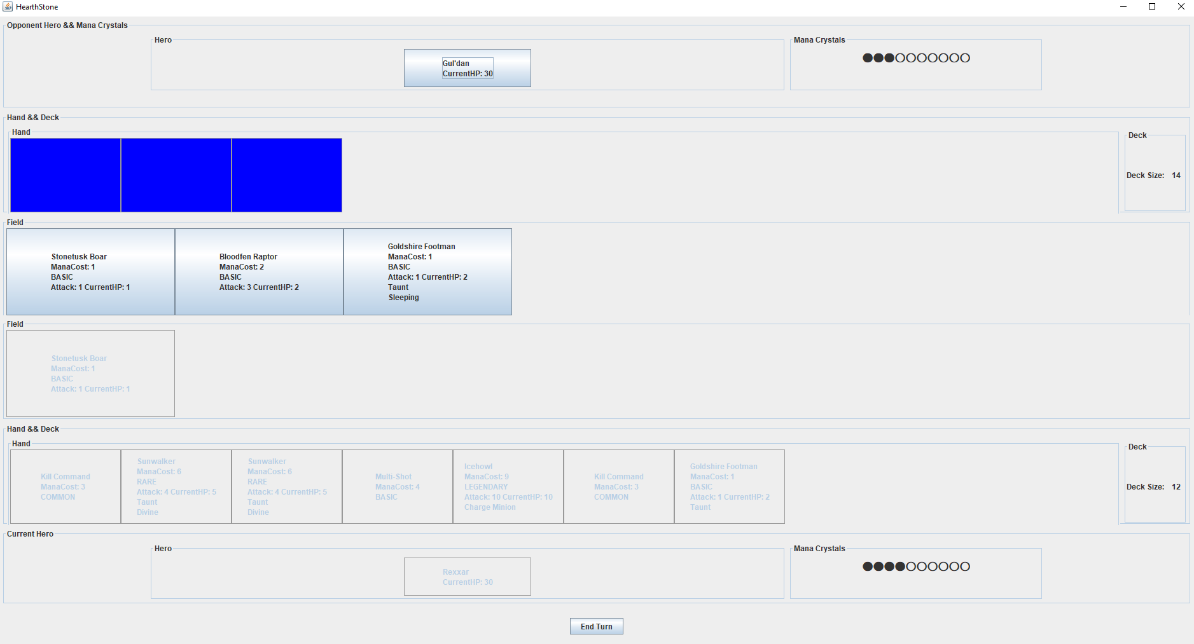Attack With Minion:

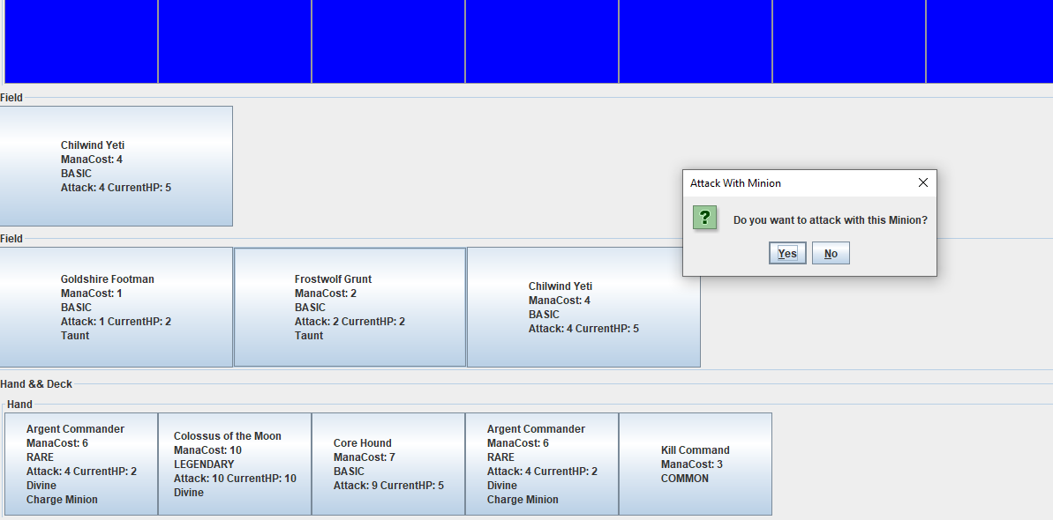To attack with a Minion the user must select a minion from the Field after clicking on a minion a window will appear to confirm that you want to attack with this minion after that the user must choose the minion or the hero that will be attacked.

Hero Power:

To use the Hero Power the user must click on his Hero to activate it. Then a window will appear to confirm if you want to use Hero Power. 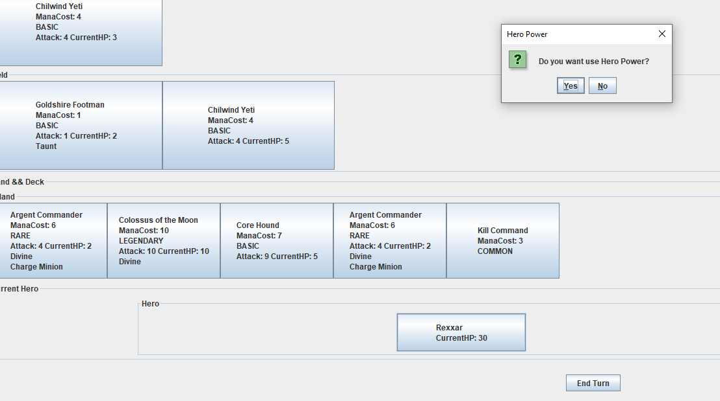

If the Hero doesn’t require another data to be chosen you have to select it after confirming that you will use the Hero Power.

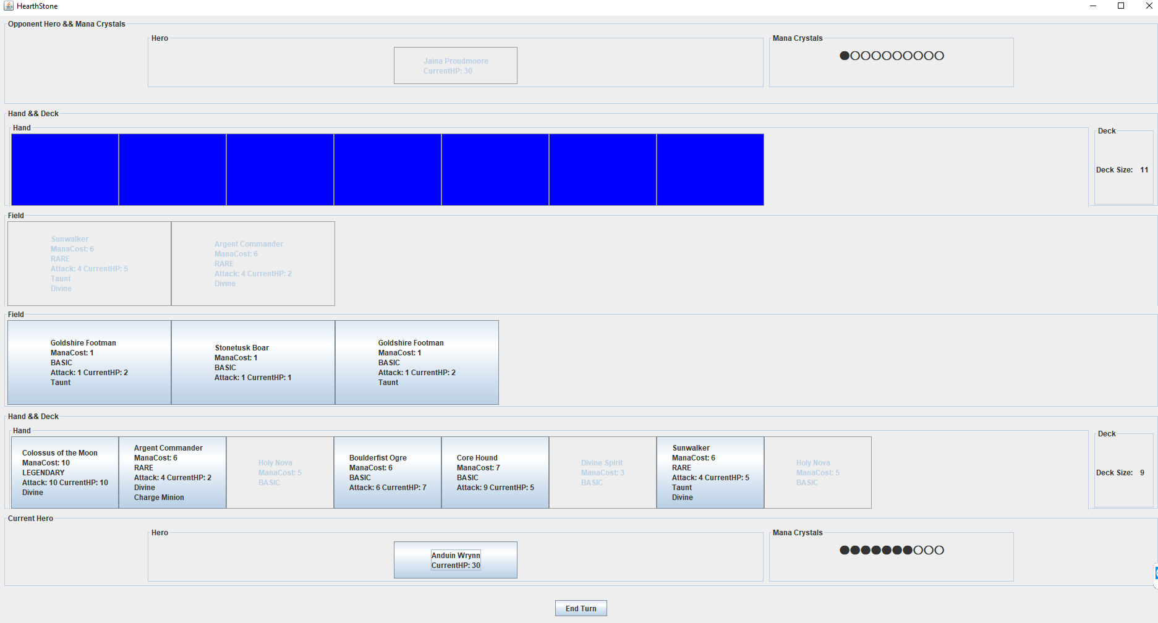

Game Over:

When the game is finished a window is opened to display the winner player name and a play again button and exit button.

